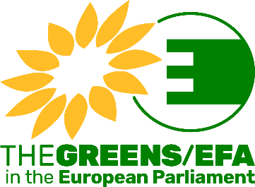

INTERNSHIP FORM
Important: please complete this form and send it to Greens.HR@europarl.europa.eu, together with your CV (Europass or resume) and a motivation letter.

First name:
Family name:
Requested start date:
Mother tongue:
Other EU languages:
Area of university studies:
(ex: law, economics, EU studies, journalism, etc.)
Area of previous professional experience, if any:

You can select the Greens/EFA cluster/department in which you would like to carry out an internship (maximum 2 choices possible in total). Please note that this information is indicative and if selected, you may be offered an internship in one of the other clusters/departments according to our needs and the positions available.

CLUSTER/DEPARTMENT | 1st choice  (ONLY 1 choice possible) | 2nd choice  (ONLY 1 choice possible)
Cluster Ecological Transition
(AGRI, ENVI, ITRE, PECH and TRAN Committees)
Cluster Green & Social Economy, including digital
(BUDG, CONT, ECON, EMPL, IMCO, and REGI Committees + digital coordination)
Cluster Rights & Democracy
(AFCO, CULT, FEMM, JURI, LIBE and PETI Committees)
Cluster International Affairs
(AFET, DEVE, INTA Committees + DROI and SEDE Sub-Committees)
Communications department
(Press unit, Social Media unit, Website and Publications unit, Audio-visual unit)
Outreach & Campaigns department
(Outreach unit, Campaigns in the following fields: environment, social, economy, digital, rights and democracy, international)
Central Secretariat
(Office of the Secretary General or the Deputy Secretary General in charge of HR, Logistics & Events unit)

