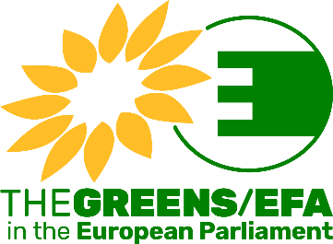

INTERNSHIP FORM

Your application shall consist of the following documents (in this order) in English:
- The completed internship form
- Your CV (Europass or resume)
- A motivation letter
Please save your application in PDF format as one file as follows “Application_your name” (example: Application_Smith) and send it by email to the Greens/EFA Human Resources department: Greens.HR@europarl.europa.eu

First name:
Family name:
Requested start date:
Nationality:
Mother tongue:
Other EU languages:
Area of university studies:
(ex: law, economics, EU studies, journalism, etc.)
Area of previous professional experience, if any:

You can select the Greens/EFA cluster/department in which you would like to carry out an internship (maximum 2 choices possible in total). Please note that this information is indicative and if selected, you may be offered an internship in one of the other clusters/departments according to our needs and the positions available.

CLUSTER/DEPARTMENT | 1st choice  (ONLY 1 choice possible) | 2nd choice  (ONLY 1 choice possible)
Cluster Ecological Transition
(AGRI, ENVI, ITRE, PECH and TRAN Committees)
Cluster Green & Social Economy, including digital
(BUDG, CONT, ECON, EMPL, IMCO, and REGI Committees + digital coordination)
Cluster Rights & Democracy
(AFCO, CULT, FEMM, JURI, LIBE and PETI Committees)
Cluster International Affairs
(AFET, DEVE, INTA Committees + DROI and SEDE Sub-Committees)
Communications Strategy department
(Press unit, Social Media unit, Website and Publications unit, Audio-visual unit)
Campaigns & Outreach department
(Outreach unit, Campaigns in the following fields: environment, social, economy, digital, rights and democracy, international)
Central Secretariat
(Team of the Secretary General responsible for the coordination of political activities of the Group or office of the Deputy Secretary General in charge of HR, Finance, IT, Logistics & Events units)

